

PROJECT REPORT

ON

NATURAL DISASTER DATA ANALYSIS

Presented By:

Neha Navgale (16286910)

Naga Srividya Varanasi (16269844)

**MOTIVATION**

We had a doubt since from long time about the origin of Natural disasters, why are they occurring, from where are they starting, what is the intensity of these disasters, impact on humans and many other factors that are causing these hazardous calamities to take place.

So, we grabbed the opportunity to take this topic as part of our cloud computing project to enhance our understanding more and to answer to our questions. Let us see what the scientists are thinking and what came out from their findings.

* Researchers are debating whether natural disasters can teach us something about human behavior.
* Insight could be used to protect us in the future.
* Unfortunately, we can’t prevent natural disasters or predict them with 100 percent certainty.
* But we can find out whether we can make our societies more resilient to natural disasters, so that people can get through them. We can do that by looking at the ways in which our societies have handled natural disasters in the past.

**OBJECTIVE**

Our main objective was to get answers to our questions from the motivation and to have deep understanding of these tragedies. We categorized our objectives and things to be achieved as the following,

* Understanding the trend of occurrence of disaster phenomenon, it’s impact on humanity and economy.
* Analysis of all-natural disasters happened all over the world.
* Generate insights and visualizations (analysis charts):
  1. Number of reported disasters
  2. Human impacts from disasters
  3. Economic Damage
  4. Death rates

**QUESTIONS FROM PAST DATA**

* Which natural disaster is deadliest and which regions of world are prone to that disaster?
* What is the top deadliest event occurred in past?
* Countries which are prone to disasters?
* Is it increasing or decreasing over the year?
* How do natural disasters affect the economy?
* By looking into the past data can we predict the probability of occurrence of event in future.

For these questions we found the solutions, and observed the trend over the years with substantial increase in the population, global warming, carbon mono emissions etc.

**DATA**

Now, let’s go back to know the source of data, where we got from and how did we get to know about this data and many more.

**Source:**

* EM-DAT (Emergency Events Database), Centre for Research on the Epidemiology of Disasters (CRED): EM-DAT is a global database on **natural and technological disasters**, containing **essential core data** on the occurrence and effects **disasters** in the world, from 1**900 to present**.
* EM-DAT is maintained by the **Centre for Research on the Epidemiology of Disasters (CRED)** at the School of Public Health of the University catholique de Louvain located in Brussels, Belgium.
* <https://www.emdat.be/>

**Date/year duration**:

Data available from 1900 – Mar 2019.

**Size of data:**

6949 records for following 6 types of natural disaster event occurred all over the world, namely:

1. Earthquake
2. Flood
3. Volcanic Activity
4. Wildfire
5. Storm
6. Landslide

**How it was collected:**

The database is compiled from various sources, including UN agencies, non-governmental organizations, insurance companies, research institutes and press agencies.

* EM-DAT includes all disasters from 1900 until the present, conforming to at least one of the following criteria:

1. 10 or more people dead
2. 100 or more people affected
3. The declaration of a state of emergency
4. A call for international assistance

* EM-DAT is internally updated on a **daily basis**. However, the publicly accessible information is updated **every 3 months**, once that all the data has been **validated** and **cross-checked** using different sources

**Accuracy of data:**

<http://www.cred.be/sites/default/files/Quality_accuracy_disaster_data.pdf>

**SAMPLE DATA**

From the data, the following columns are available like disaster type, iso, country name, year, occurrence, total deaths, injured, affected, homeless and total damage.

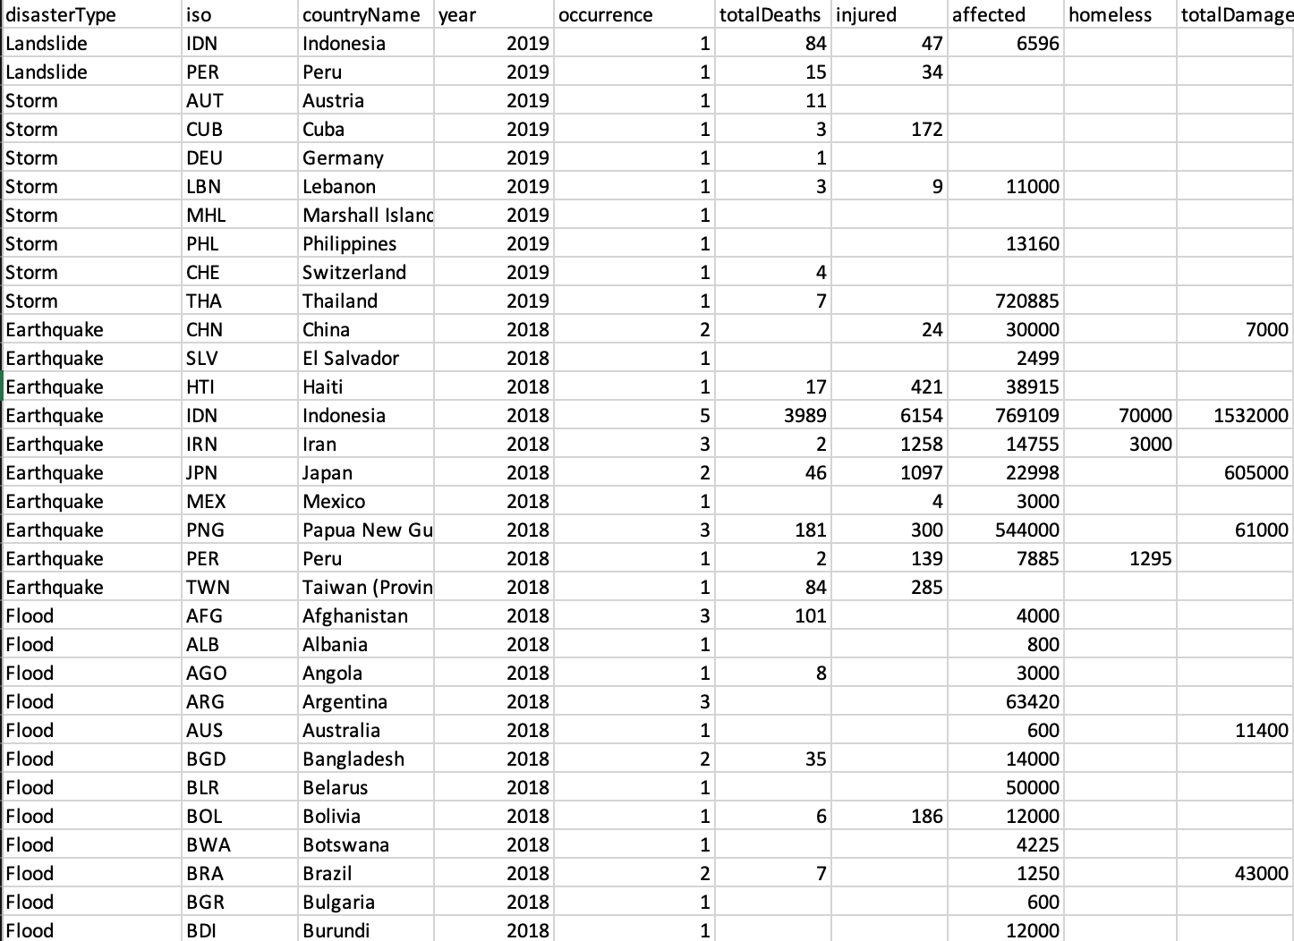

**OUR FINDINGS**

These are the answers to some of the questions which we found out using our analysis.

* Trend of natural disaster is increasing over the years.
* Economy damaged by natural disaster has also increased over the years.
* Flood is the deadliest disaster happened so far.
* USA is highly vulnerable to natural disasters.
* In 1931, the deadliest natural disaster occurred in China, affected approx. 40 lac people.
* Countries falls under the seismic zone are highly prone to Earthquakes.

**TOOLS,TECHNOLOGIES, LANGUAGES AND PLATFORM USED**

* Python
* Angular 7
* Html5, CSS3
* GitHub
* Pycharm
* Webstorm
* Amazon Web Service

**BLOCK DIAGRAM**

Our diagram is pretty simple, and it consists of:

1.Data in csv format

2.Using python for processing and filtering

3.Used Angular for abstraction and pattern recognition

4 Angular for comparison

5.Finally, angular for visualization.



**ARCHITECTURE**

Our main architecture consists of a user, who can see front end (which is created in Angular 7),

Flask, python using pandas library and in the back end using data in csv format.

**ANALYSIS TO FIND ANSWERS TO THE QUESTIONS**

* Analysis of Various Disasters occurred in different countries over the years
* Comparison of occurrence of different disasters in any country.
* Comparison of occurrence of a disaster between two countries.
* Locating events on Google Map.
* Empirical View

**HOMEPAGE**

Our home page looks like this.

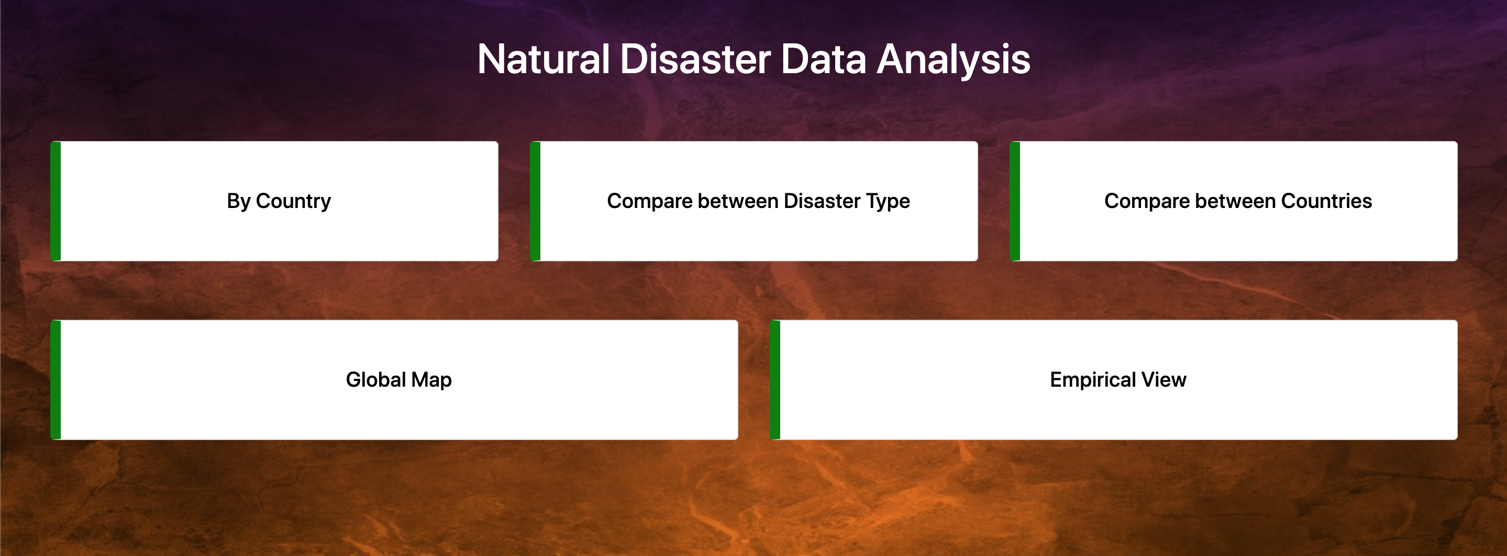

**ANALYSIS BY COUNTRY**

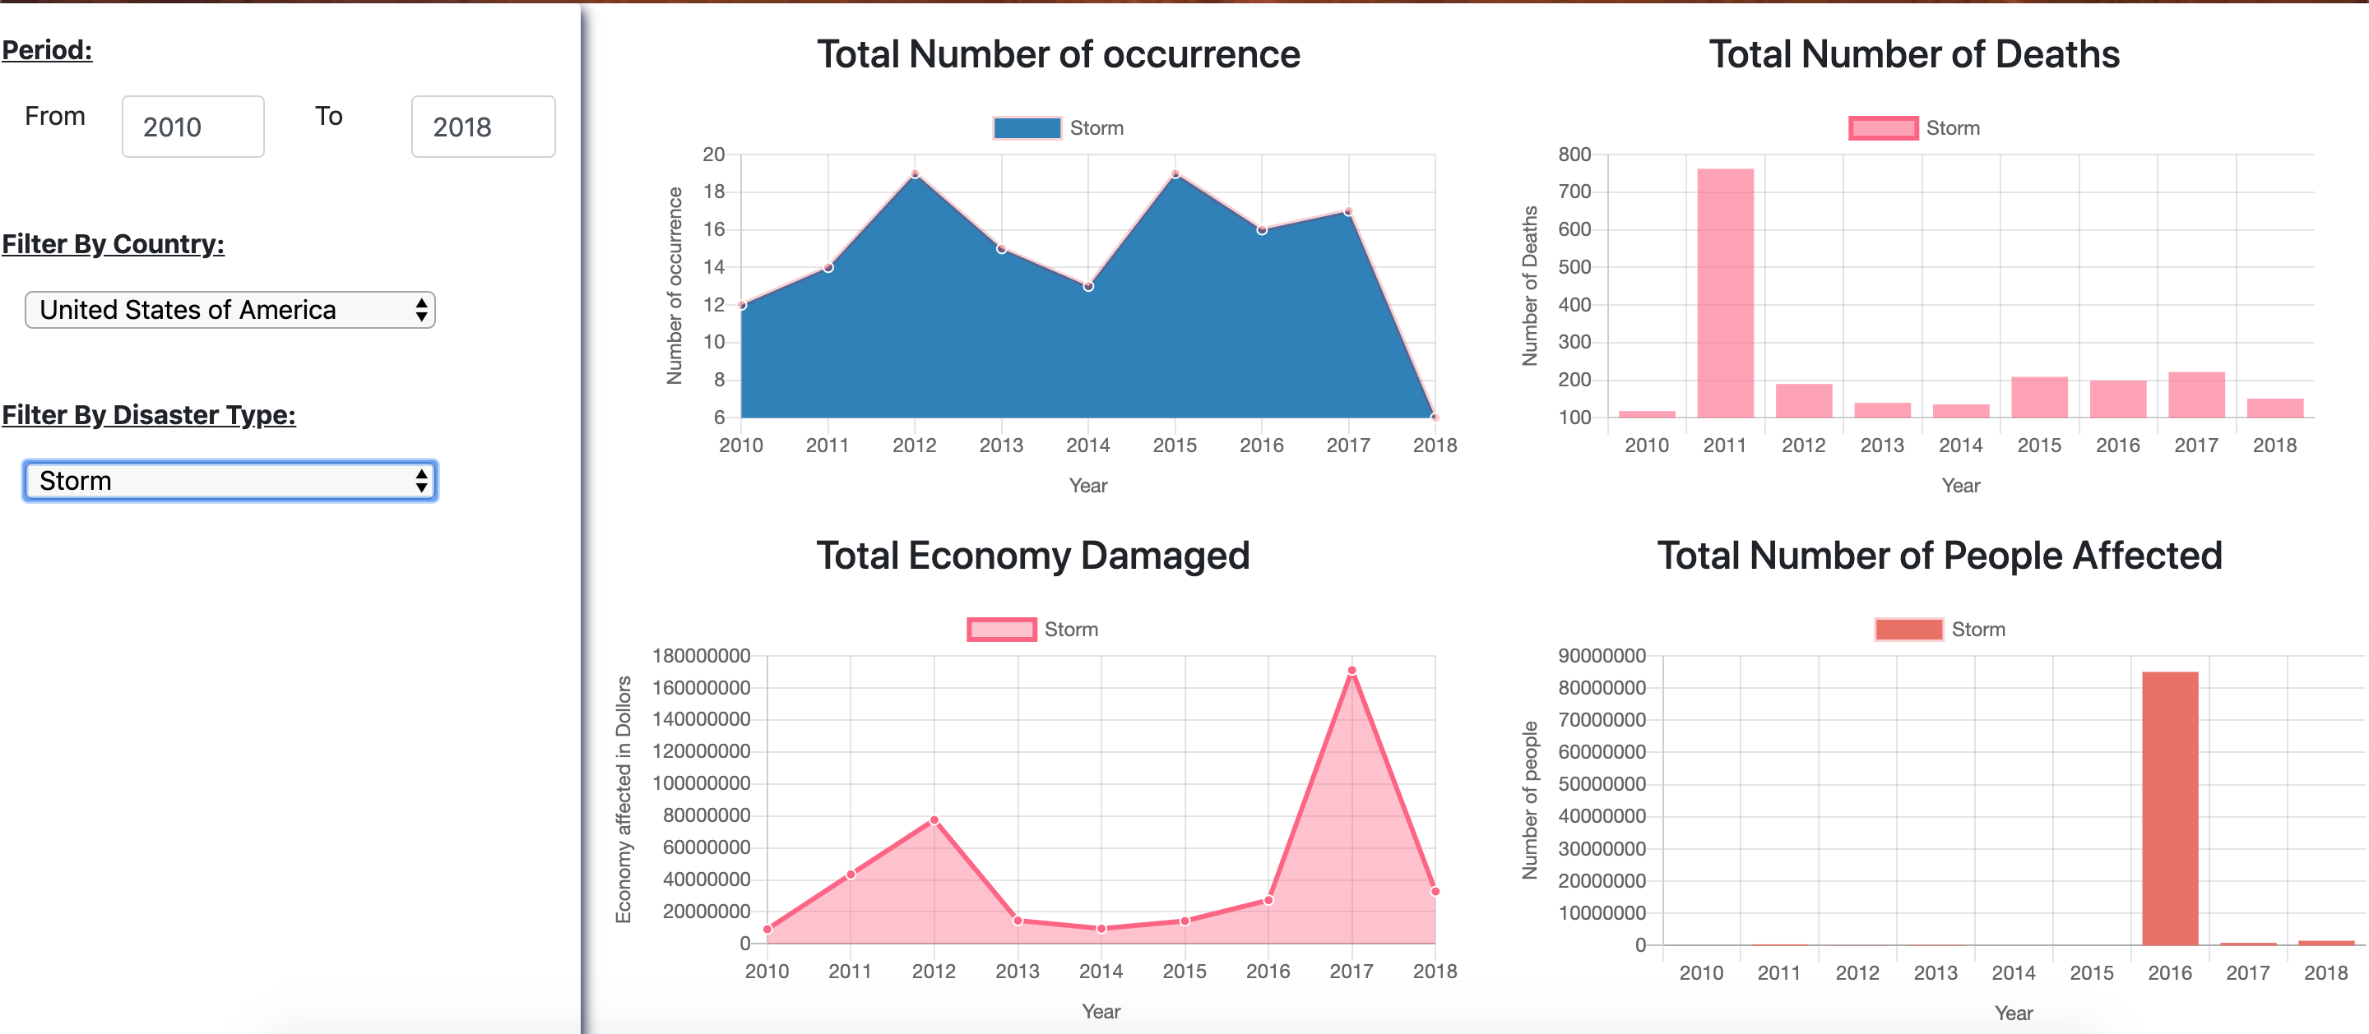

From the above figure, we can find the analysis by country by changing the country name and changing the disaster type. We can observe the total number of occurrences, total number of deaths, total economy damaged, and total number of people affected.

**COMPARISION BETWEEN DISASTER TYPES**

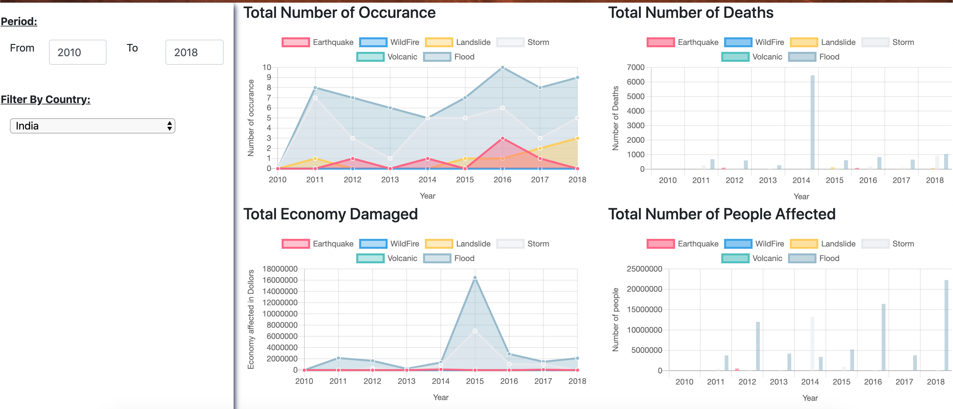

Here, we can find the analysis among different disasters with in the same country. We can find the analysis through different shapes and sizes and can analyze through these graphs.

**COMPARISON BETWEEN TWO COUNTRIES**

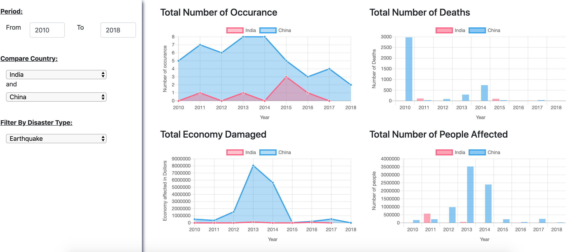

This graph is very interesting as we can find the interesting analysis among different disasters among different countries. We can also find comparison among disasters by selecting the type that we want to compare with.

**GLOBAL MAP**

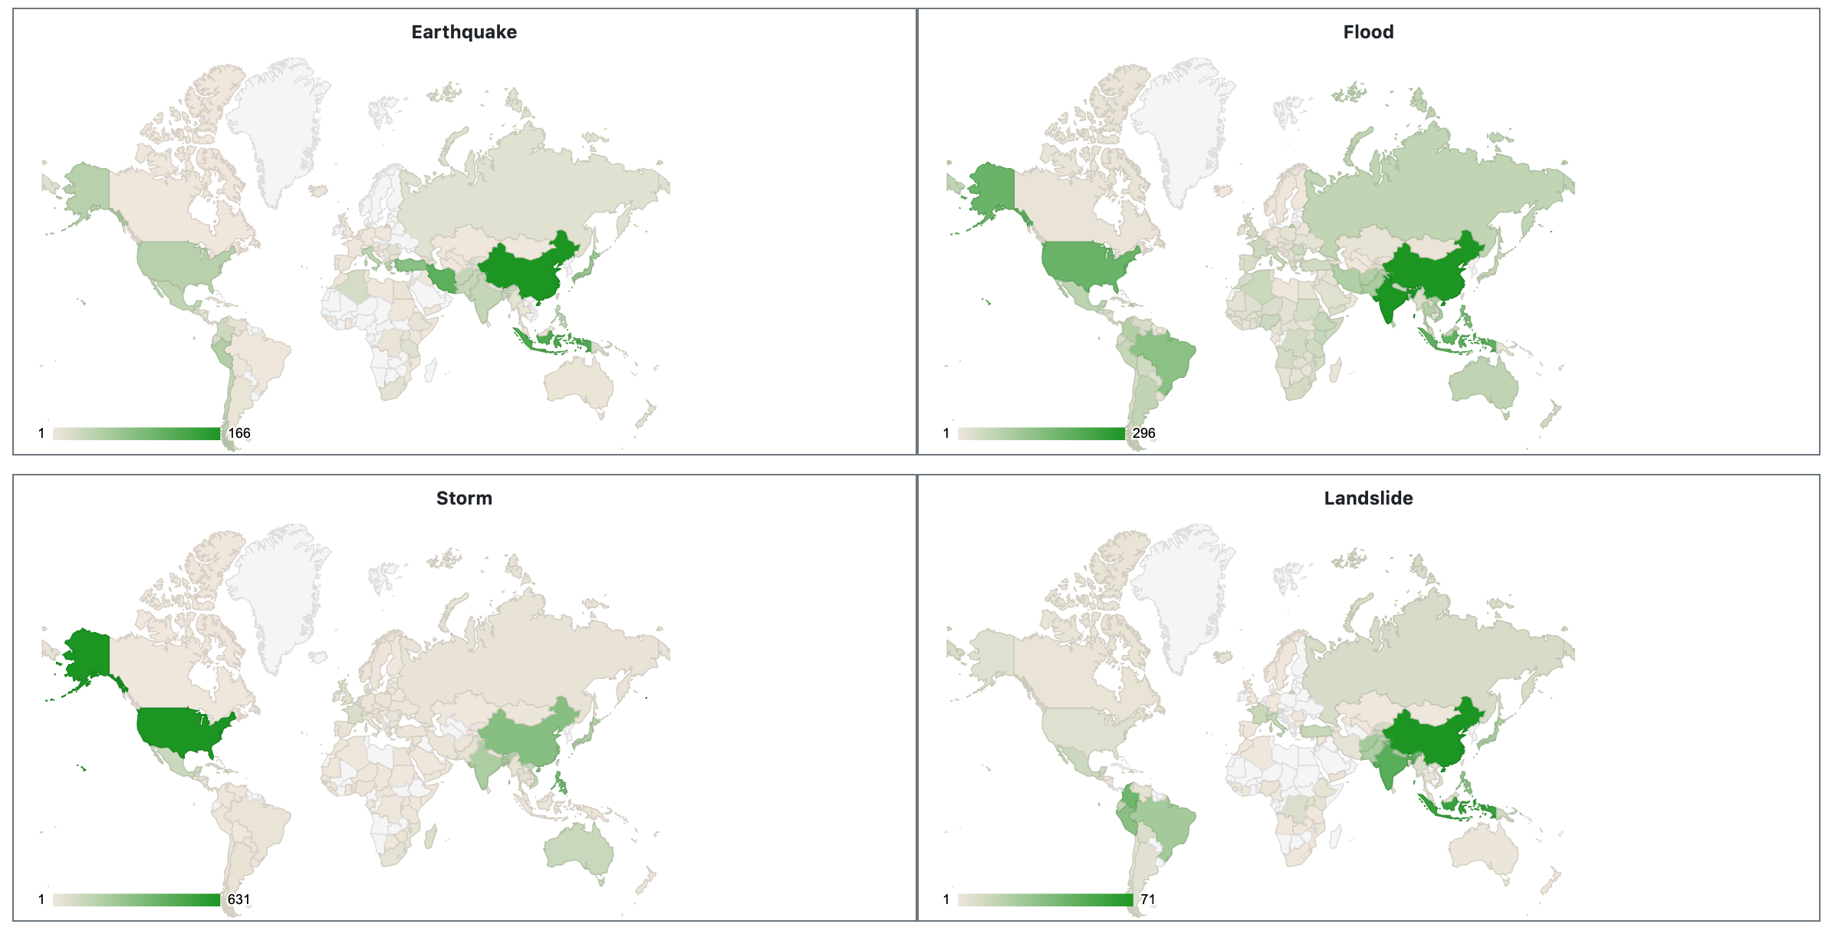

For this graph, we have used the Google maps API for the global display of the disasters in the world map. The ones with the dark green color usually indicate the country with the highest number of disasters that have occurred.

**SUGGESTIONS RECEIVED**

These are some of the suggestions that we have from our peers which helped us in improving our project more efficiently and made us come up with better analysis of the data.

* Provide filtering for each graph. – Incorporated
* NLP technique to answer the questions – Future Enhancement
* Prediction of occurrence of event – Future Enhancement
* Locate events on Map in order to understand the regions prone to disasters – Incorporated

**CHALLENGES**

We faced few challenges while doing the project, here are few challenges which we came through,

* Locating events on Google Map.
* Locating countries name on Google Map.
* Difficulty with embedding Amazon Quick sight dashboard in Angular 7 web application.

**LEARNING OUTCOME**

Here are the learning outcomes of our project which we gained while doing the analysis, these are interesting and can be used as experience for other projects as well.

* Learned to use Google Map package in Angular
* Learned to gain insights on data and visualize using Angular.

* We learned how to deploy Angular and Python application on AWS.
* We learned how natural disaster has impacted the world

**FUTURE WORK**

As we know that every project has a future scope, similarly even our project has the ability to answer multiple questions as shown below:

* Prediction of occurrence based on previous data
* Identify the parameters affecting the occurrence of natural disaster and analysis of its variation.
* Implement NLP technique to find answers of questions.

**REFERENCES**

* <https://www.codementor.io/dushyantbgs/deploying-a-flask-application-to-aws-gnva38cf0>
* <http://www.cred.be/sites/default/files/Quality_accuracy_disaster_data.pdf>
* The effect of natural disasters on economic activity in US counties: a century of data. <https://www.nber.org/papers/w23410.pdf>
* The impact of natural disasters on human development and poverty at the municipal level in Mexico. <https://www.preventionweb.net/english/hyogo/gar/background-papers/documents/Chap3/LAC-overview/Mexico/Mexico.pdf>

**GITHUB LINK**

<https://github.com/NehaNavgale/CloudComputingProject>